Chenai Holistic Home Care Agency Ltd Carbon Reduction Plan

Supplier Name: Chenai Holistic Home Care Agency Ltd
Publication Date: 15/12/2023
Commitment to Achieving Net Zero
Chenai Holistic Home Care Agency Ltd is dedicated to reaching Net Zero emissions by 2030. This commitment underscores our responsibility towards environmental sustainability and aligns with our ethos of care and wellbeing, not just for individuals but for the planet.
Baseline Emissions Footprint
Chenai Holistic Home Care Agency Ltd has tracked its greenhouse gas emissions for the past 9 years. These records establish a baseline for measuring future reductions and guide our strategies for decreasing emissions.
Baseline Year: 2014/15 (01/02/2014 to 31/01/2015)
Our baseline emissions calculations are based on detailed energy usage data, waste management records, and business travel logs from 2014. We used the GHG Protocol Corporate Accounting and Reporting Standard for consistent and precise emissions accounting.
During the baseline year, Chenai Holistic Home Care Agency Ltd:
- Operated 2 facilities, contributing mainly to Scope 1 and Scope 2 emissions.
- Employed 30 staff, whose commuting and business travel comprised our Scope 3 emissions.
- Engaged with 3 suppliers, included in Scope 3 emissions using a spend-based approach.

Baseline Year Emissions:
Baseline Year: 2014/15 (01/02/2014 to 31/01/2015)
EMISSIONS | TOTAL (tCO2e)
Scope 1 | 49.75
Scope 2 | 81.03
Scope 3 total | 984.59
- Waste | 0.10
- Business Travel | 420.16
- Employee Commuting | 571.33
- Upstream T&D | Not relevant
- Downstream T&D | Not relevant
Total Emissions | 1122.37

Current Emissions Reporting
Reporting Year: 2022/23 (01/02/2022 to 31/01/2023)
EMISSIONS | TOTAL (tCO2e)
Scope 1 | 12.09
Scope 2 | 62.35
Scope 3 total | 228.90
- Waste | 0.04
- Business Travel | 157.07
- Employee Commuting | 71.79
- Upstream T&D | Not relevant
- Downstream T&D | Not relevant
Total Emissions | 303.34

Emissions Reduction Targets
Our targets towards Net Zero are:
- Reduce Scope 1 emissions by 20% by 2030.
- Decrease Scope 2 emissions by 30% by 2030.
- Work with suppliers to lower Scope 3 emissions by 80% by 2030.

Progress against these targets can be visualised in the accompanying graph, which compares projected reductions against actual year-on-year emissions
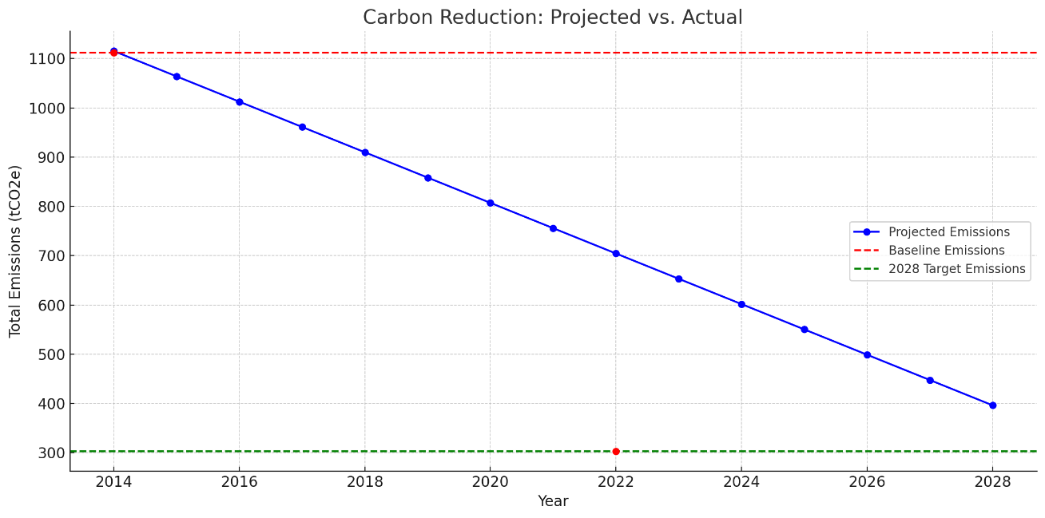
Completed Initiatives:
- Renewable energy transition (solar panels, green energy contracts).
- Fleet electrification.
- LED lighting and smart HVAC systems.
- Waste reduction and recycling programs.
- Employee engagement in sustainability.
- Electronic monitoring
- No plastic use policy
- Rotors to reduce paper use
Ongoing and Planned Projects:
- Advanced energy management systems.
- Building retrofitting for energy efficiency.
- Sustainable supply chain development.
- Expansion of renewable energy sources.
- Carbon offsetting initiatives.
- Promoting telecommuting and flexible work schedules.
- Green IT initiatives.
- R&D in environmentally friendly services.
- Water conservation efforts.
- Use of Electric Vehicles
Declaration and Sign Off
This Carbon Reduction Plan has been completed following PPN 06/21 and associated guidance and reporting standards for Carbon Reduction Plans.
Emissions have been reported and recorded by the published reporting standard for Carbon Reduction Plans and the GHG Reporting Protocol corporate standard13 and use the appropriate Government emission conversion factors for greenhouse gas company reporting14.
Scope 1 and 2 emissions have been reported following SECR requirements, and the required subset of Scope 3 emissions have been reported following the published reporting standards for Carbon Reduction Plans and the Corporate Value Chain (Scope 3) Standard15.
This Carbon Reduction Plan has been reviewed and signed off by the board of directors (or equivalent management body).
Signed on behalf of the Supplier:
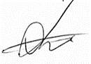
Date: 15/12/2023

